Final Report

Physical Computing

*Spring 2018*

Professors:

**Marc Langheinrich**

**Ivan Elhart**

**Anton Fedosov**

**Simulator Weather Lamp**

(SWL)

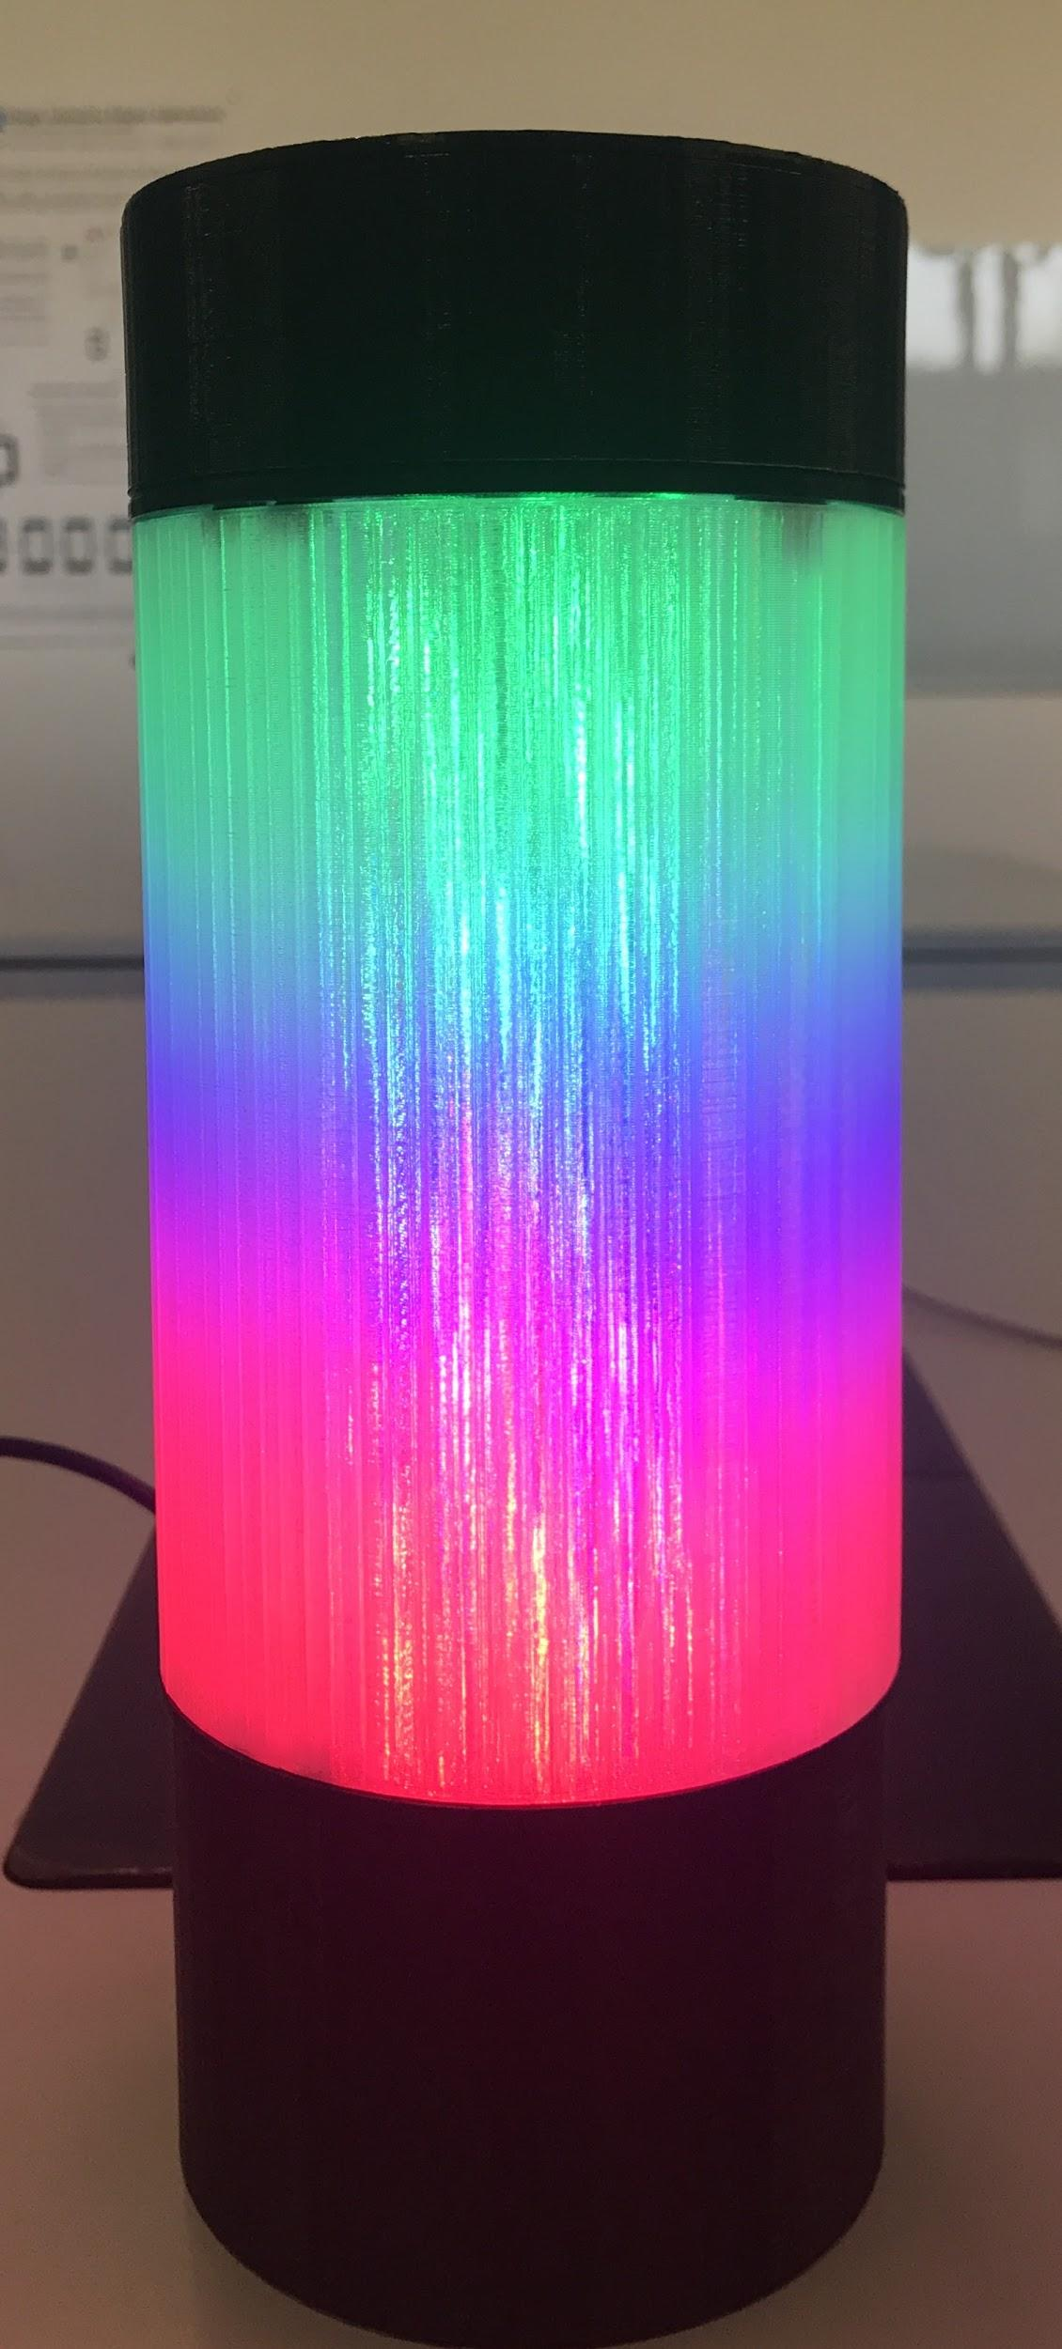

Sebastian Hidalgo, Tong Pan, Amirehsan Davoodi

*“Bring the outside to the inside”*

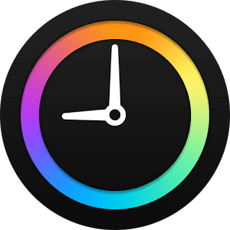

Introduction

For our physical computer project, we decided to build a Simulator Weather Lamp (SWL). The main function of the lamp is to acquire the forecasted weather condition from the internet and provide to the user an ambient light with the color resembling that of the weather. Additional features discuss more in detail in the following sections were added that enabled the user to interact with the device and receive information regarding the current weather and states of the lamp.

# Motivation

Our motivation behind this project was inspired by the amazing natural scenery and nice weather conditions that we are able to experience in Lugano. More often than not for most of us, our daily routine confines us to being in closed spaces for long periods of time. Let it be in schools, hospitals, or at work, these places with its surrounding walls keep us from admiring and enjoying the beauty of nature outside. With this in mind, we decided to approach the problem in a different way, so instead we asked: why not bring what we are missing outside these walls inside?   
Whether it is the suiding view of rainfall or the relaxing view of a bright sunny day, we wanted to bring these sensations as close as possible to our daily life. From this, we created the motto of our project to be:

*“Bring the outside to the inside”*

Prototype Description

Basic Functionalities

As described earlier, SWL is an smart lamp that connects to the internet and retrieves the weather forecasted. SWL then lights up with the color resembling that of the weather. The location (city) from where the weather is retrieved can be chosen from five predetermined locations, giving the user a wider range of options. Picture 1. shows three different weather scenarios with the lamps’ corresponding response.

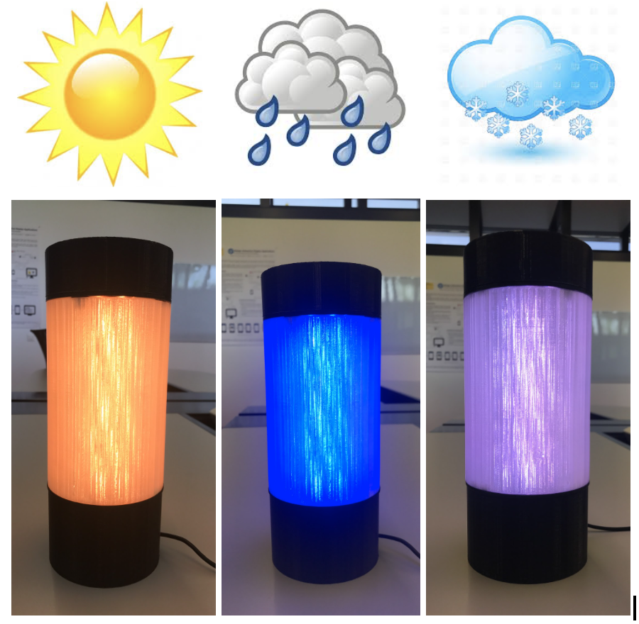

Picture 1. Square SWL of different color displays

Additional, the lamp comes equipped with a small OLED display where information about the weather and states of the lamp are shown. SWL also comes equipped with the possibility to decrease or increase the light intensity based on the users desired. In the following sections, we will discuss the architecture of the lamp along with the hardware and software implementation perform in this project.

# Components and Architecture

Physical Structure

Picture 2 shows the physical structure (left) of the lamp alongside an *“X-ray”* version (right) showing the different hardware components and its physical location within the lamp used in the implementation of this project.

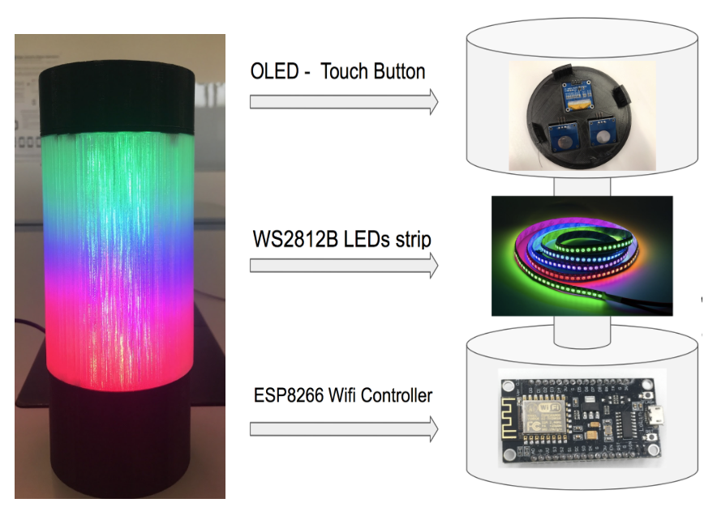

Picture 2. Lamp’s Structure

Lamp Frame (Body)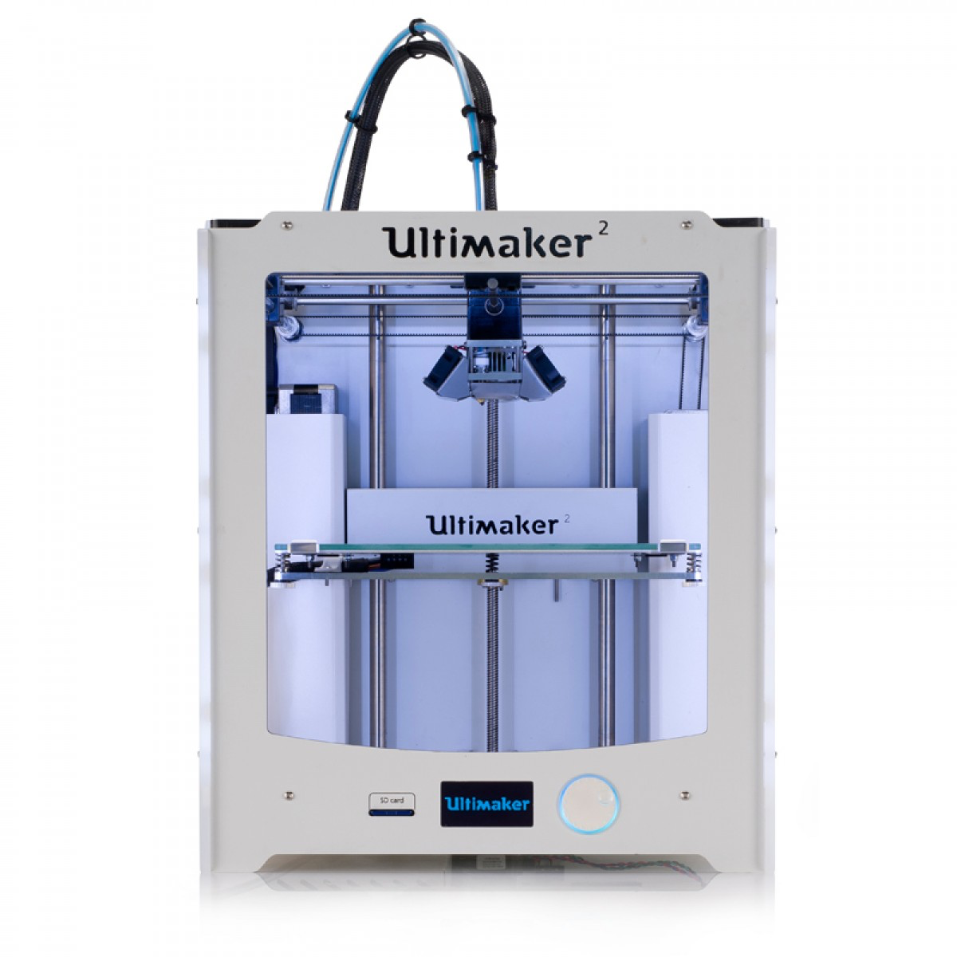

We decided to custom 3D print the entire body of the lamp in order to satisfy our own design desires and be able to accommodate the electronic hardware components without space limitation. For this process, we used the *SketchUp* google tool to design and generate our 3D drawings and then used the *Ultimaker Cura* software tool to prepare our 3D models for printing. Picture 3 shows the process following during 3D printing.

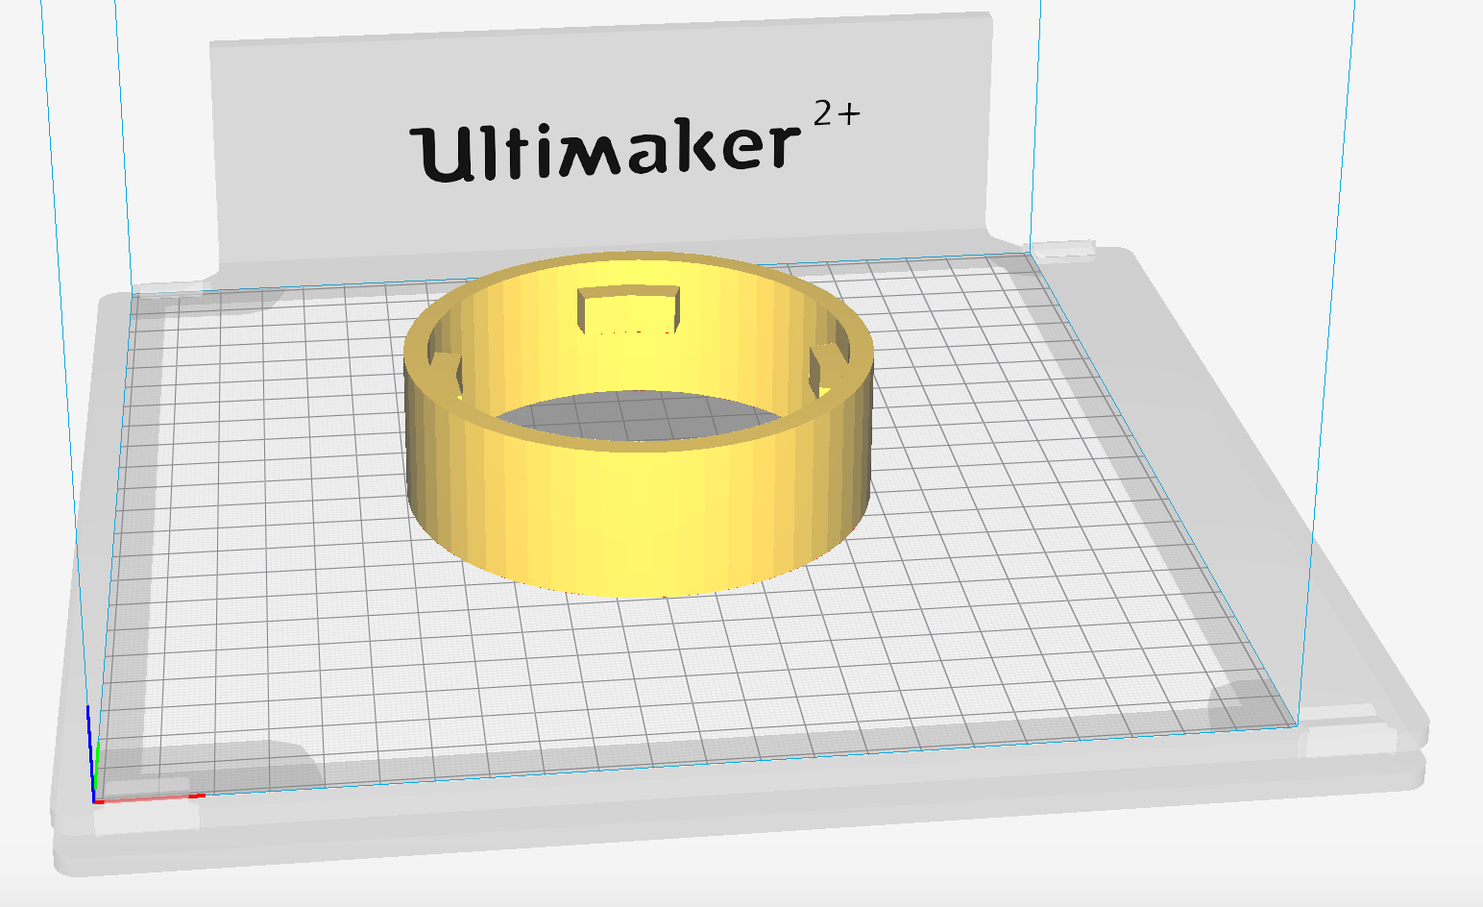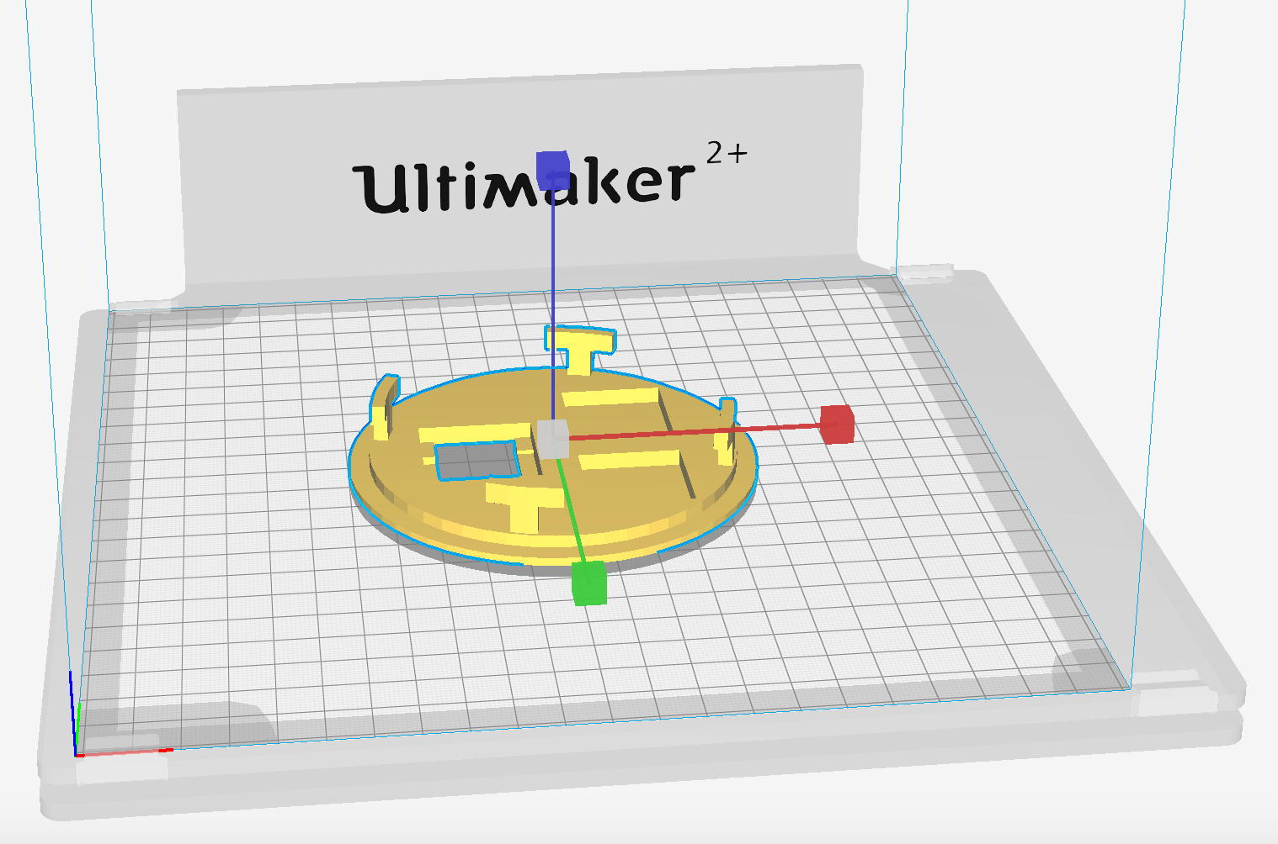

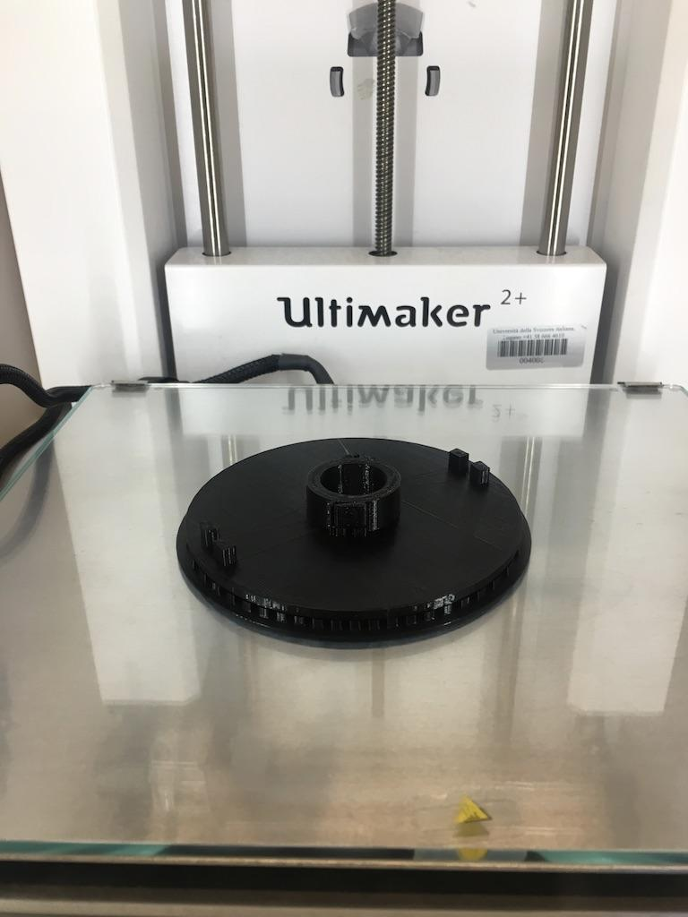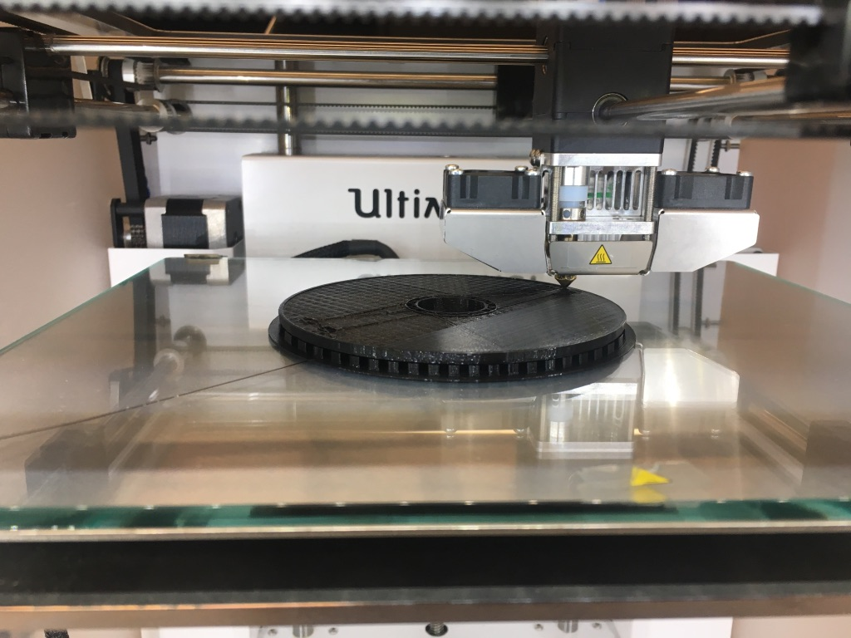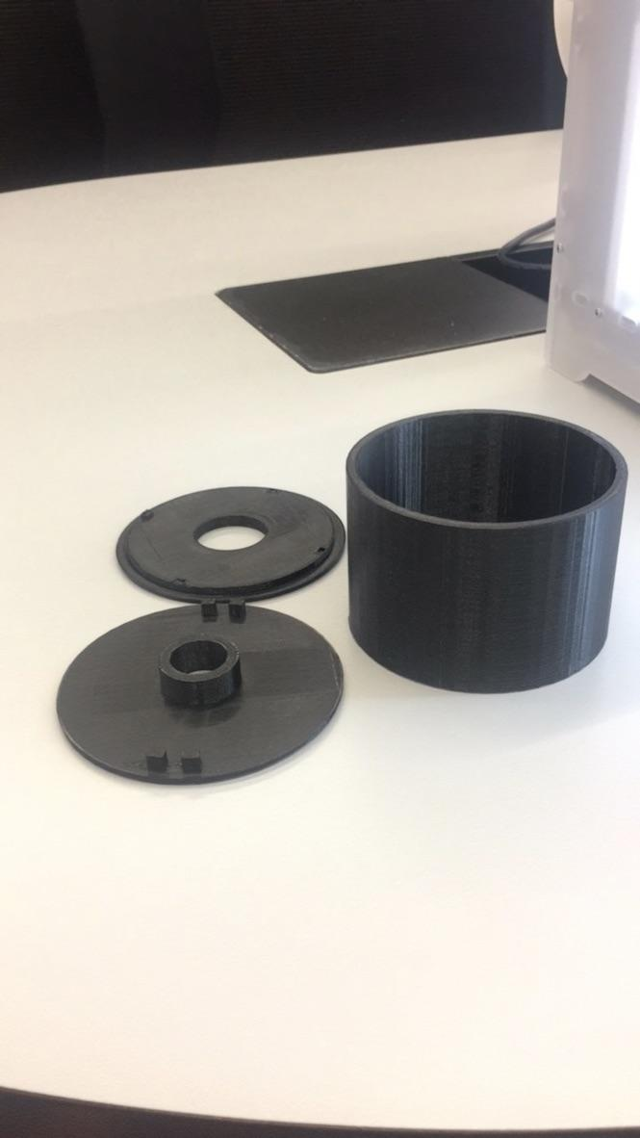

Picture 3. 3D Printing process

Hardware Implementation



Figure TBD. SWL Block Diagram

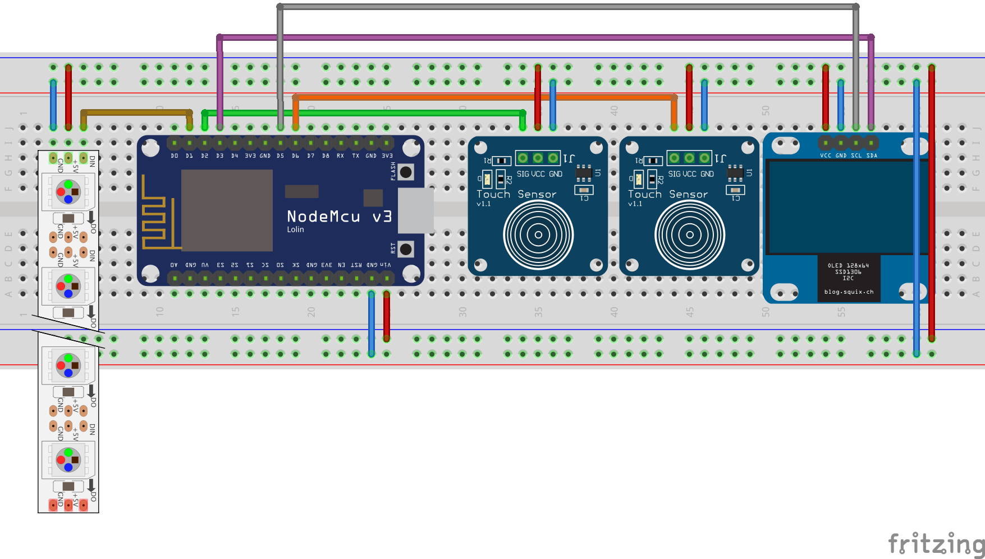

Figure Breadboard Schematic (created using Fritzing)

ESP8266 Wifi-Microcontroller - As shown in Picture TBD, this arduino based controller provided all the necessary input and output pins needed for the different lamp functionalities. Additionally, the built-in WiFi capability allowed us to connect the lamp to a wireless network and retrieve the necessary weather information.

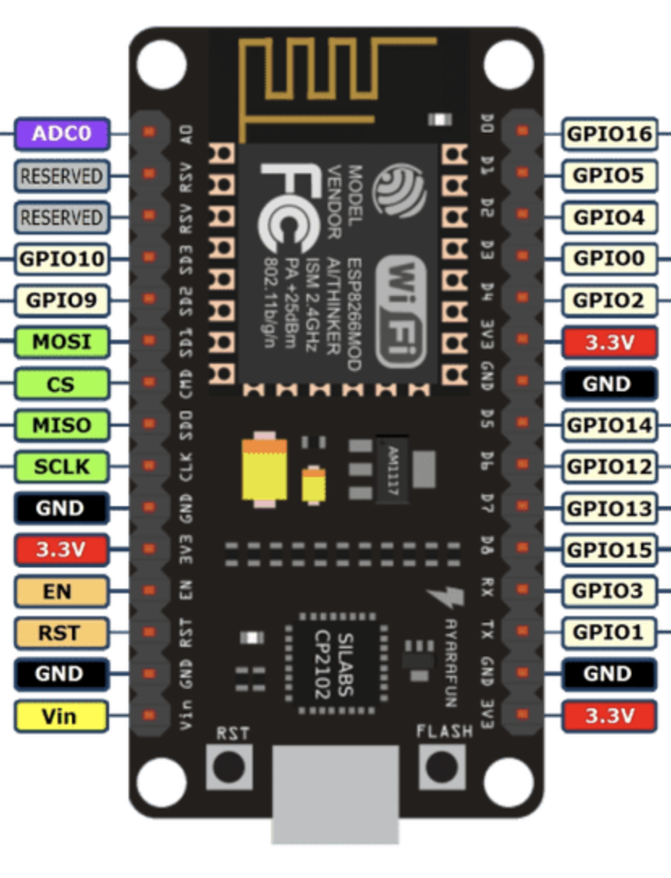

Picture TBD. ESP8266-Wifi Microcontroller

The following Table 1. details the mapping of the pins to the different hardware components in the lamp.

Table 1. ESP8266-Wifi Microcontroller

|  |  |  |  |  |
| --- | --- | --- | --- | --- |
| **Pin Number** | **Type (I/O)** | **Connected to** | **Pin type** | **Description** |
| D3  D5 | output | OLED | SDA  SCL | Display control |
| D2  D6 | input | Touch Sensors | 2x SIG | Input sensors |
| D1 | output | LEDs | Din | LED control |

# 

# WS2812B LEDs- This multicolor LED strip (RGBW), provided us with enough flexibility in terms of color combinations. The communication protocol used is I2C which allowed us to map to every individual LED independently and control its RGBW values for color coding as well as intensity.

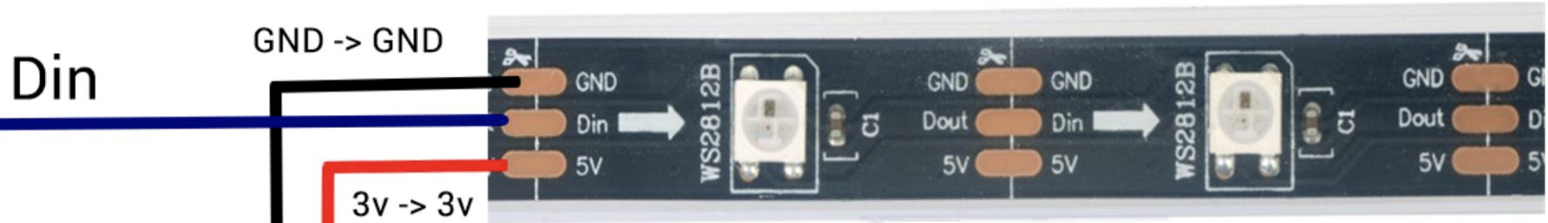

Picture TBD. WS2812B LEDs

OLED display **- SSD1306 is a single-chip CMOS OLED/PLED driver with controller for organic / polymer light emitting diode dot-matrix graphic display system. It consists of 128 segments and 64commons. This IC is designed for Common Cathode type OLED panel.**

**The SSD1306 embeds with contrast control, display RAM and oscillator, which reduces the number of external components and power consumption. It has 256-step brightness control. Data/Commands are sent from general MCU through the hardware selectable 6800/8000 series compatible Parallel Interface, I2C interface or Serial Peripheral Interface. It is suitable for many compact portable applications, such as mobile phone sub-display, MP3 player and calculator, etc.**

Digital Touch sensor (Buttons) **-**

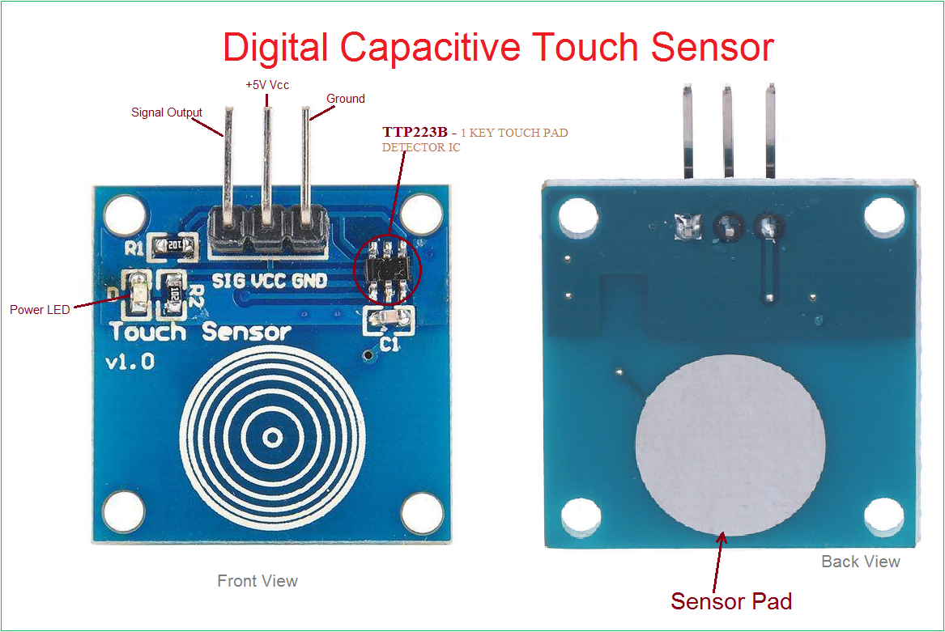

Picture TBD. TTP223B Capacitive Touch Sensor

# Software Implementation

Used libraries

The language used for programming all functionalities of SWL was C/C++ using the arduino platform. The main software libraries were used to communicate and control some of the different hardware components. These libraries are presented as following:

**WiFi-library-**  There is an embedded WiFi module for the ESP8266 version of the arduino or more specifically NodeMCU. For using this network adaptor to connect to internet and send or receive weather information or current time from APIs. We used the ESP8266WiFi library which is based on WiFi.h from Arduino WiFi shield library.

Using this library we simply connected to an access point with the name “ssid” and password “password” by the following command

WiFi.begin(ssid, password);

Then we checked the status of connection by this command.

while (WiFi.status() != WL_CONNECTED) {}

**API-Clock -** For getting the current time of the selected location we get the current time using **WorldClockClient** library which sending a http request to the free and open time API with the following URI

[https://thingspeak.com/channels/CHANNEL_ID/feeds.json](https://thingspeak.com/channels/CHANNEL_ID/feeds.json?results=2&api_key=API_KEY)?results=2&api_key=API_KEY

**ArduinoJson - library -** This library allowed to parse the data we are interested on and process the received json file to extract needed information. For instance, get the description of the current weather based on the corresponding element of the received json file or get the maximum or minimum temperature of the day.

**LED strip (Adafruit NeoPixel) Library-** This library allowed us to control each LED in particular (number of LEDs, color and intensity are the parameters of it.) through use of I2C communication protocol. I2C assigns a particular address to each LED enabling individual control of each LED.

**LCD (OLEDDisplayUi) - library** - This library allowed us to display figures or text on the SSD1306 OLED display as simple as running the following lines of codes in which we set the alignment of the text and its font in addition to the starting point to write the string and the string it-self.

display.setTextAlignment(TEXT_ALIGN_CENTER);

display.setFont(ArialMT_Plain_10);

display.drawString(64, 32, "WELCOME!");

In addition to the simple version of printing text on the screen there are some helper functions at this library which can show different text on the screen using slide show effects.

SWL Logic: State Machine

The code written for SWL follows a state machine implementation topology as shown in Picture 2. This state machine can be broken down into three main states:

1. OFF-State
2. Initialization-State
3. On-State

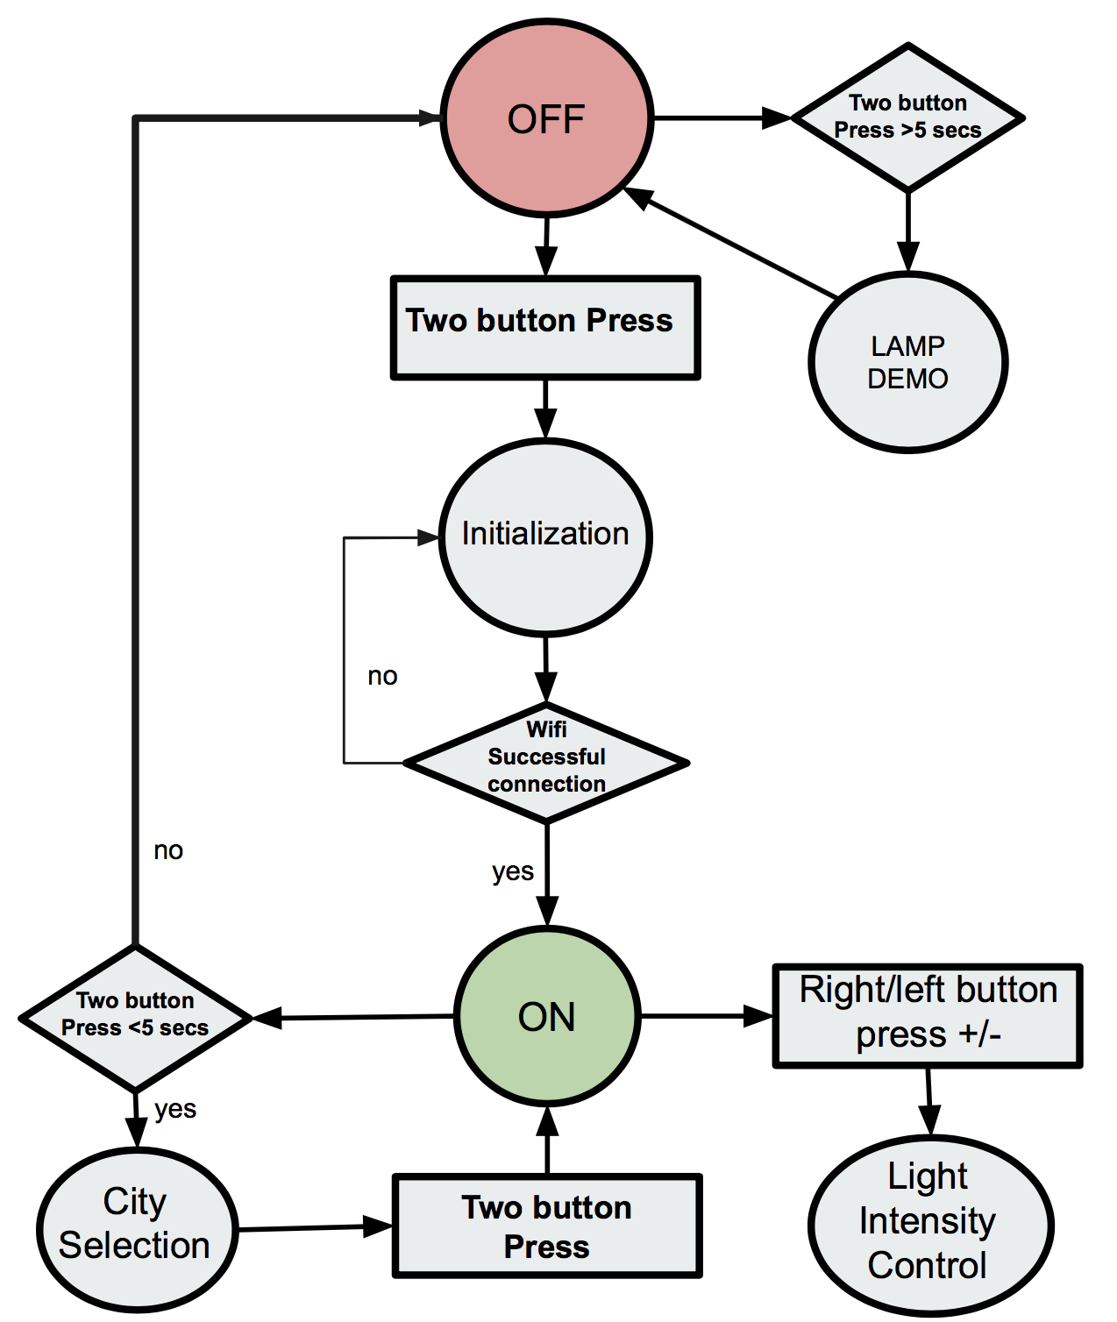

Picture 2. SWL State Machine

Off-State

The Off-State depicted by the red circle in the state machine in Picture 2 is the initial state SWL enters as soon as power is applied to the unit. This can be done any source of power rated at +5 volts and 1 Amp of current. i.e. (USB-connection).

During this stage, the ESP8266 Wifi-Controller is awake waiting to receive inputs coming from the touch buttons while at the same time displaying information to the LCD screen as shown in Picture TBD.

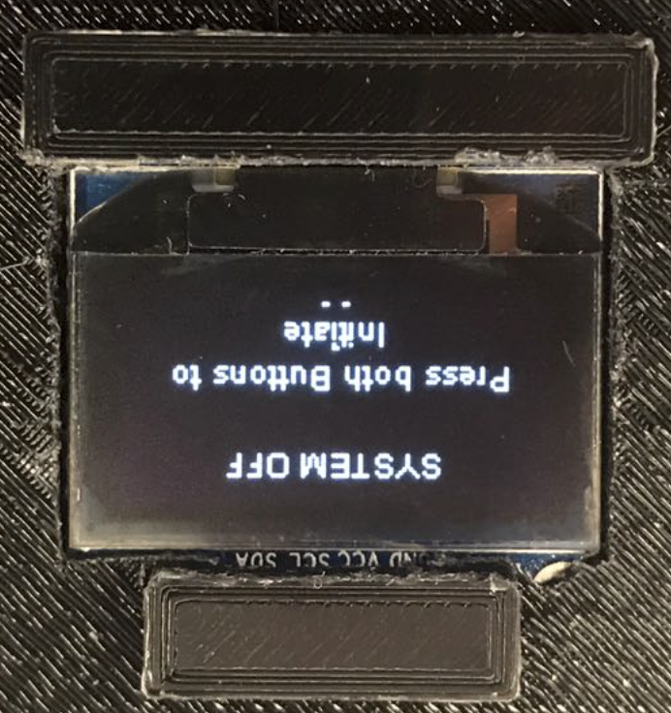

Picture TBD. Off-State LCD display

From the Off-State the lamp can enter Demo-mode or Initialization-State. If pressed for more than 5 seconds, it will enter Demo-mode. During the Demo-mode, the lap will exercise all its possible functionalities. The LCD is commanded to display a certain weather condition i.e sunny and at the same time the LEDs will be commanded to turn yellow. This will repeat for all types of weather conditions that have been programmed in the lamp. Following the weather demonstrations, light intensity increase/decrease will also be shown with the LCD showing a progress bar accordingly.

If instead, normal operation of the lamp is desired, both buttons would need to be pressed for less than 5 seconds and the lamp will enter Initialization-State.

Initialization-State

During the Initialization-State, the Wifi-Controller will start search for a valid internet connection given a pre-configured SSID name and password. Once a successful internet connection is achieved the controller will start searching for a valid API connection. Again, once a valid API connection is achieved the Initialization-State is completed and the lamp will enter On-State. At all times, the progress of this process is broadcasted to the LCD and no inputs from the touch buttons are enabled.

ON-State

When the lamp enters the On-State, the weather condition received at that time will trigger the lap to switch the LEDs to the color resembling that particular weather condition as shown before. Analogously, the LCD will display additional information of the current location where the weather information is coming from as shown Picture TBD. For this particular case- Lugano.

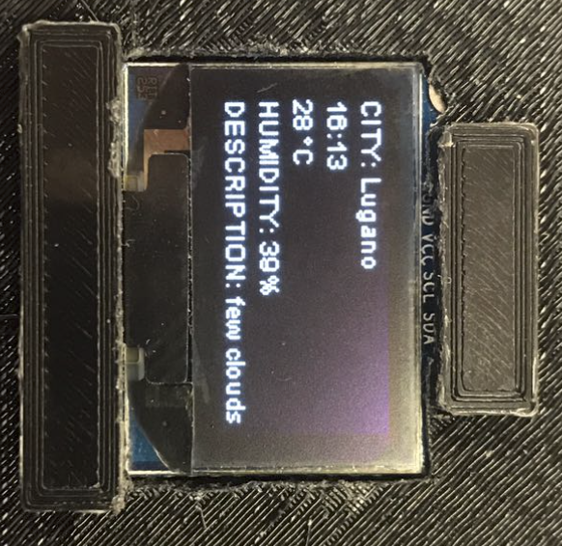

Picture TBD. On-State LCD display

Additionally, all functionalities exercised during the Demo-mode and more are available. As show in Picture TBD. From this state, the light intensity can be control through the input of the touch buttons to the controller. Similarly, the LCD will react to this action by showing a progress bar displaying the percentage intensity.

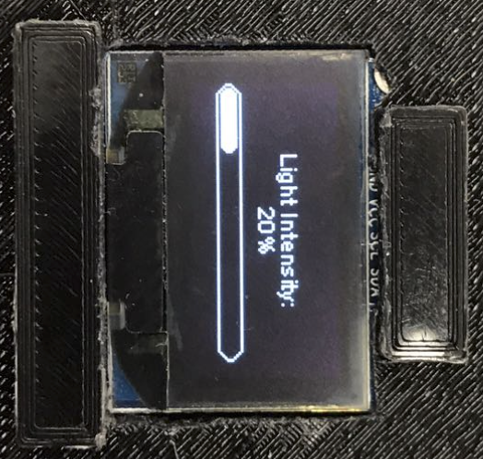

Picture TBD. Light Intensity Progress Bar

As shown in Picture TBD, another functionality incorporated in the design is the possibility of selecting the weather location from five predetermine cities around the world. It is possible to enter this city selection by pressing down on both buttons for less than 5 seconds. Picture TBD below shows an example of this menu. Here, the cursor can be moved up or down with either of the two touch buttons and a location can be selected by pressing on both buttons for a few seconds.

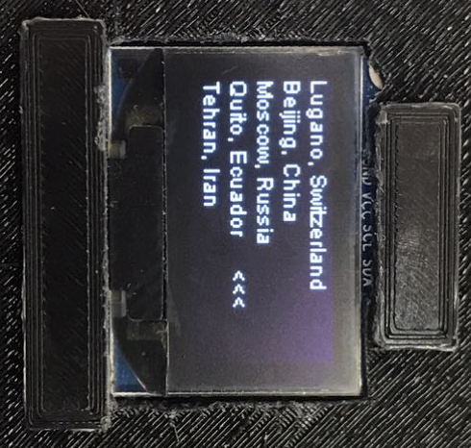

Picture TBD. City Selection Menu

This selection will bring the lamp back into the On-State and the displayed will be update with the new city selection just as shown in Picture TBD. Similarly the light in the Lamp will be updated to the current weather of the new location.

Finally, by holding down both buttons for more the 5 seconds the lamp can turn-off, or in other words, brought back to the Off-State.

SWL will communicate with the internet and get the latest weather fee. This information will be transmitted through wi-fi to the microcontroller where it will then light up the LEDs and play sound based on the current

# Final Results

Overall, all of the functionalities targeted during the proposal stage of the project were successfully met. The results met in this project were as followed:

1. 3D printed body lamp - completed
2. Weather API implementation- completed
3. Lamp Software functionalities implementation - completed
4. Touch buttons implementation - completed
5. LCD display implementation - completed
6. LEDs implementation - completed.

The only function that was not implemented was the expansion/optional functionalities of the of speakers playing pre-recorded weather sounds correlated to the weather condition like rain or wind e.g.

Describe your final result - is the prototype "complete" or are functionalities missing? If it is not complete, what functionality is missing? *(In part 5, please provide a discussion on why you were not able to reach the envisioned result)*. Did you evaluate the prototype in any way? If so, what measurements have you done and what are the results?

# Reflection / Discussion

Describe the development of your project. Describe how you approached the project, what did work fine, what turned out to be infeasible, and how you dealt with difficulties along the way. Again, your description should enable a person reading your report to avoid the pitfalls that you experienced.

# Appendix

## Source Code (Implementation)

We coded the logic of this project using C/C++ programming language which is a low level language and was compiled at Arduino IDE to the machine executable code and this code uploaded to NodeMCU version of the Arduino devices using USB cable. It is worth to mention that programing for Microcontrollers like Arduino devices needs to be done in a very careful way and sometimes it could be very challenging task. For instance, if you want to have a specific task like updating weather information every 5 minutes you can code it by having a delay for five minutes. However, this simple solution is not working if you add more task to do for your controller. In other worlds, if you delay the processor you cannot do other task at the delay time. This kind of differences between normal programing and programing for Microcontrollers was somehow limited us to simply write isolated code for different wanted functionality of the project and combine them together by calling this functions in a sequential way.

For example, first we divide the code into different modules. List of modules are the followings:

* controlling the light intensity using touch buttons
* showing text on the OLED display
* getting weather information from internet (API) using http request
* getting the current time of the selected city from internet (API) using http request

However, after coding each task separately combining all this codes together was really difficult because of the sequential characteristic of microcontroller programing. For our project, even we coded the implemented code again when we failed to combine the two pre-coded modules.

The final version of the code is commented and highlighted at the following.

#**include** <ESP8266WiFi.h>  
#**include** <ESP8266HTTPClient.h>  
#**include** <ArduinoJson.h>  
#**include** <Adafruit_NeoPixel.h>  
#**include** <SPI.h>  
#**include** <Wire.h>  
#**include** <Adafruit_GFX.h>  
#**include** <WorldClockClient.h>  
//#include <Adafruit_SSD1306.h>  
#**include** "SSD1306Wire.h"  
#**include** "OLEDDisplayUi.h"  
#**include** "icons.h"  
  
// All our states in our lamp  
#**define** S_TURNOFF 1  
#**define** S_INITIALIZATION 2  
#**define** S_WORKING 3  
#**define** S_CITY_SELECTION 4  
  
// All different colors of our LEDs  
#**define** c_c_white 1  
#**define** c_c_blue 2  
#**define** c_c_purple 3  
#**define** c_c_yellow 4   
  
// demo time limit   
#**define** demo_time_limit 5000  
#**define** city_selection_timer_limit 5000  
  
#**define** Led_pin D1  
#**define** NUMPIXELS 60  
Adafruit_NeoPixel pixels = Adafruit_NeoPixel(NUMPIXELS, Led_pin, NEO_RGB + NEO_KHZ800);  
  
// Initialize the OLED display using brzo_i2c  
// D3 -> SDA  
// D5 -> SCL  
  
// Initialize the OLED display using Wire library  
SSD1306Wire **display**(0x3c, D3, D5);  
OLEDDisplayUi **ui** ( &display );  
  
  
  
  
**int** led_light_up_number = NUMPIXELS; //- 20;  
  
**int** TouchSensor1 = D2; //connected to Digital pin D2  
**int** TouchSensor2 = D6; //connected to Digital pin D6  
**float** brightness = 255; // Initialize Brightness  
**float** fadeAmount = 25.5;  
boolean booting_up = true;  
  
// WiFi credentials  
**const** **char**\* ssid = "UC_PCOMP";  
**const** **char**\* password = "pr3pAr3d";  
  
// api credentials  
**const** String api_url = "http://api.openweathermap.org/data/2.5/weather?&units=metric";  
**const** String api_token = "&appid=134f461a6f03f55040a08b8935cd2f85";  
  
String cities_name [] = {"Lugano, Switzerland", "Beijing, China", "Moscow, Russia", "Quito, Ecuador", "Tehran, Iran"};  
String cities_weather_api [] = {"&q=Lugano,CH", "&q=Beijing,CN", "&q=Moscow,RU", "&q=Quito,EC", "&q=Tehran,IR"};  
  
// time library configuration  
String cities_time [] = {"Europe/Zurich", "Asia/Shanghai", "Europe/Moscow", "America/Guayaquil", "Asia/Tehran"};  
WorldClockClient **worldClockClient**("en", "CH", "E, dd. MMMMM yyyy", 4, cities_time);  
**int** current_location_index = 0;  
  
  
// weather informations  
String current_city_name = "";  
String current_time = "";  
String current_temperature = "";  
String current_humidity = "";  
String current_weather_desc = "";  
String current_net_stat = "";  
String current_api_stat = "";  
String current_weather_id = "";  
**int** current_led_color = 0;  
  
**static** **int** state = S_TURNOFF; // initial state is (S_TURNOFF = 1) which means the "off" state.  
**static** **unsigned** **long** start_timer; // To store the "current" time for delays.  
**static** **unsigned** **long** thunderstorm_timer; // timer for switching color of the LED for the thunderstorm  
**static** **unsigned** **long** demo_timer;  
**static** **unsigned** **long** city_selection_timer;  
  
**int** delayval = 20;// Delay for a period of time (in milliseconds).  
  
**void** **off_all_leds**(){  
 **for** ( **int** led_num = 0; led_num < led_light_up_number; led_num++ ) {  
 pixels.setPixelColor(led_num, pixels.Color(0, 0, 0));  
 }  
 pixels.show(); // This sends the updated pixel color to the hardware.  
 delay(delayval); // Delay for a period of time (in milliseconds).  
}  
  
**void** **bootup_effect**(){  
 **int** color_mode = 1;  
 **for** ( **int** led_num = 0; led_num < led_light_up_number; led_num++ ) {  
 **if** (led_num % 20 == 0) {  
 **if** (color_mode == 1) {  
 color_mode = 2;  
 } **else** **if** (color_mode == 2) {  
 color_mode = 3;  
 } **else** **if** (color_mode == 3) {  
 color_mode = 1;  
 }  
 }  
  
 // set the color of leds  
 **if** (color_mode == 1) {  
 pixels.setPixelColor(led_num, pixels.Color((**int**)brightness, 0, 0));  
 } **else** **if** (color_mode == 2) {  
 pixels.setPixelColor(led_num, pixels.Color(0, (**int**)brightness , 0));  
 } **else** **if** (color_mode == 3) {  
 pixels.setPixelColor(led_num, pixels.Color(0, 0 , (**int**)brightness));  
 }  
  
 pixels.show(); // This sends the updated pixel color to the hardware.  
 delay(delayval); // Delay for a period of time (in milliseconds).  
 }  
 Serial.println("starting color motion");  
}  
  
**void** **increase_light_intensity**(**int** sensor1) {  
 //INCREASES LED intensity  
 **if** (sensor1 == HIGH) {  
 delay(800);  
 **while** (digitalRead(TouchSensor1) == HIGH && digitalRead(TouchSensor2) != HIGH) {  
 **if** (brightness <= 255 - fadeAmount) {  
   
 // LED affect  
 brightness = fadeAmount + brightness;  
 pixels.setBrightness((**int**)brightness);  
 pixels.show(); // This sends the updated pixel color to the hardware.  
 delay(delayval);  
  
 Serial.println("brightness");  
 Serial.println((**int**)brightness);  
 }  
 display.clear();  
 // LCD intensity display  
 // draw the progress bar  
 display.drawProgressBar(0, 32, 120, 10, brightness/2.55);  
   
 // draw the percentage as String  
 display.setTextAlignment(TEXT_ALIGN_CENTER);  
 display.drawString(64, 15, String(lround(brightness/2.55)) + "%");  
 display.display();  
 delay(800);  
 display.clear();  
  
 start_timer = millis()+59000;  
 }  
 }  
}  
  
**void** **decrease_light_intensity**(boolean sensor2) {  
 //DECREASES LED intensity  
 **if** (sensor2 == HIGH) {  
 Serial.println("decreasing light");  
 delay(800);  
 **while** (digitalRead(TouchSensor2) == HIGH && digitalRead(TouchSensor1) != HIGH) {  
 **if** (brightness > fadeAmount) {  
 brightness = brightness - fadeAmount;  
   
 // LED affect  
 pixels.setBrightness((**int**)brightness);  
 pixels.show(); // This sends the updated pixel color to the hardware.  
 delay(delayval);  
   
 Serial.println("brightness");  
 Serial.println((**int**)brightness);  
 }  
 display.clear();  
 // LCD intensity display  
 // draw the progress bar  
 display.drawProgressBar(0, 42, 120, 10, brightness/2.55);  
   
 // draw the percentage as String  
 display.setTextAlignment(TEXT_ALIGN_CENTER);  
 display.drawString(64, 15, "Light Intensity:");  
 display.drawString(64, 25, String(lround(brightness/2.55)) + "%");  
 display.display();  
 delay(800);  
 display.clear();  
  
 start_timer = millis()+59000;  
 }  
 }  
}  
  
// LCD welcome Screen  
**void** **greeting_sc**(){  
 display.clear();  
 // draw circle for showing for greeting on the screen  
 drawCircle();  
 delay(2000);  
 display.clear();  
 display.setTextAlignment(TEXT_ALIGN_CENTER);  
 display.setFont(ArialMT_Plain_10);  
 display.drawString(64, 32, "WELCOME!");  
 display.display();  
 delay(2000);  
}  
  
// LCD goodbye Screen  
**void** **goodbye_sc**(){  
 display.clear();  
 display.setTextAlignment(TEXT_ALIGN_CENTER);  
 display.setFont(ArialMT_Plain_10);  
 display.drawString(64, 32, "Goodbye For Now!");  
 display.display();  
 delay(2000);  
 display.clear();  
}  
  
// LCD system is off  
**void** **system_off_sc**(){  
 display.clear();  
 display.setTextAlignment(TEXT_ALIGN_CENTER);  
 display.setFont(ArialMT_Plain_10);  
 display.drawString(64, 6, "SYSTEM OFF");  
 display.drawStringMaxWidth(64, 32, 128,"Press both Buttons to Initiate");  
 display.drawString(64, 40, "-\n- -\n- -\n- -\n- -");  
 display.display();  
}  
  
  
**void** **drawCircle**(**void**) {  
 **for** (**int16_t** i=0; i<display.getHeight(); i+=2) {  
 display.drawCircle(display.getWidth()/2, display.getHeight()/2, i);  
 display.display();  
 delay(10);  
 }  
 delay(1000);  
 display.clear();  
}  
  
  
  
**bool** **check_api_stat**() {  
 HTTPClient http;  
 http.begin(api_url+api_token+cities_weather_api[current_location_index]); //Specify the URL  
 **int** httpCode = http.GET(); //Make the request  
 **if** (httpCode > 0) { //Check for the returning code  
 http.end(); //Free the resources  
 **return** true;  
 } **else** {  
 http.end(); //Free the resources  
 **return** false;  
 }  
  
   
}  
  
**void** **get_weather_info**() {  
   
 HTTPClient http;  
 http.begin(api_url+api_token+cities_weather_api[current_location_index]); //Specify the URL  
 **int** httpCode = http.GET(); //Make the request  
  
 **if** (httpCode > 0) { //Check for the returning code  
 String json = http.getString();  
   
 Serial.println(json);  
 DynamicJsonBuffer jsonBuffer;  
 JsonObject& root = jsonBuffer.parseObject(json);  
   
 **if** (!root.success()){  
 display.clear();  
 display.setTextAlignment(TEXT_ALIGN_CENTER);  
 display.setFont(ArialMT_Plain_10);  
 display.drawStringMaxWidth(64, 32, 128, "API response ParseObject() failed!!!");  
 display.display();  
 delay(2000);  
 Serial.print("API response ParseObject() failed!!!");  
 **return**;  
 }  
 JsonObject& weather = root["weather"][0];  
 current_weather_id = weather["id"].as<String>();  
// current_weather_id = "200";  
 current_city_name = root["name"].as<String>();   
 **double** temperature = root["main"]["temp"];  
 current_temperature = String(lround(temperature));  
 current_humidity = root["main"]["humidity"].as<String>();   
 current_weather_desc = weather["description"].as<String>();  
  
 // show weather on LCD  
 show_weather_on_LCD();  
  
 // show weather on LED  
 show_weather_on_LED();  
   
 } **else** {  
 display.clear();  
 display.setTextAlignment(TEXT_ALIGN_CENTER);  
 display.setFont(ArialMT_Plain_10);  
 display.drawStringMaxWidth(64, 32, 128, "Error on HTTP request");  
 display.display();  
 delay(2000);  
 Serial.println("Error on HTTP request");  
 }  
  
 http.end(); //Free the resources  
}  
  
**void** **show_weather_on_LCD**(){  
 String line1 = "CITY: "+ current_city_name;  
 worldClockClient.updateTime();  
 String line2 = worldClockClient.getHours(current_location_index) + ":" + worldClockClient.getMinutes(current_location_index);  
 String line3 = current_temperature+" C";  
 String line4 = "HUMIDITY: "+ current_humidity +"%";  
 String line5 = "DESCRIPTION: "+current_weather_desc;  
 String line6 = "--------------------";  
 String line7 = "Network status: Connected";  
 String line8 = "API status: Connected";  
 display.clear();  
 display.setTextAlignment(TEXT_ALIGN_LEFT);  
 display.setFont(ArialMT_Plain_10);  
 display.drawString(0, 0, line1+"\n"+line2+"\n"+line3+"\n"+line4+"\n"+line5+"\n"+line6+"\n"+line7+"\n"+line8+"\n");  
 display.display();  
 // pring celcius character  
 display.drawCircle(15, 30, 1);  
 display.display();  
 delay(2000);   
}  
  
  
**void** **show_weather_on_LED**()  
{  
 /*  
 * Color mapping (API weather code ---> LED color)  
 *   
 * thunder= 2XX ---> blue<->white   
 * Rain/drizzle = 5XX,3XX ---> Blue  
 * Snow = 6XX ---> White  
 * Clear = 800 --> Yellow  
 * clouds/atmosphere = 7, 80X ---> purple   
 */  
 **char** code = current_weather_id.charAt(0);  
 **switch**(code){  
 **case** '2':  
 Serial.println("LED color is: blue<->white blinking");  
 current_led_color = c_c_blue;  
 thunderstorm_timer = millis(); // Remember the current time  
 leds_color_change(0, 0, 255);  
 **break**;  
 **case** '3':  
 **case** '5':  
 Serial.println("LED color is: Blue");  
 current_led_color = c_c_blue;  
 leds_color_change(0, 0, 255);  
 **break**;  
 **case** '6':  
 Serial.println("LED color is: White");  
 current_led_color = c_c_white;  
 leds_color_change(100,140,140);  
 **break**;  
 **case** '7':  
 **case** '8':  
 **if**(current_weather_id.equals("800")){  
 Serial.println("LED color is: Yellow");  
 current_led_color = c_c_yellow;  
 leds_color_change(140, 140, 0);  
 } **else**{  
 Serial.println("LED color is: purple");  
 current_led_color = c_c_purple;  
 leds_color_change(30,60,150);  
 }  
 **break**;  
 }  
}  
  
  
//change the color of all leds  
**void** **leds_color_change**(**int** r, **int** g, **int** b){  
 **for** ( **int** led_num = 0; led_num < led_light_up_number; led_num++ ) {  
 pixels.setPixelColor(led_num, pixels.Color(r, g, b));  
 }  
 pixels.show(); // This sends the updated pixel color to the hardware.  
 delay(delayval); // Delay for a period of time (in milliseconds).  
}  
  
//Select color to display, or demo of all settings (TBD)  
**void** **LCD_text_display**(String text){  
 display.clear();  
 display.setTextAlignment(TEXT_ALIGN_CENTER);  
 display.setFont(ArialMT_Plain_10);  
 display.drawString(64, 32, text);  
 display.display();  
 display.clear();  
}  
  
// check demo intruption  
**bool** **check_demo_intruption**(){  
 **if** (digitalRead(TouchSensor1) == HIGH || digitalRead(TouchSensor2) == HIGH) {  
 **return** true;   
 }**else** {  
 **return** false;   
 }  
}  
  
  
// demo main function  
**void** **Demo_mode**(){  
 //LCD_text_display(text, delay)  
 LCD_text_display("Initializing Lamp Demo");  
 delay(2000);  
  
 //Type of Weather displays   
 LCD_text_display("Weather Conditions Demo");  
 delay(2000);  
  
 //Clear  
 LCD_text_display("CLEAR SKY");  
 leds_color_change(140, 140, 0);  
 delay(2000);  
   
 //Clouds  
 LCD_text_display("CLOUDY");  
 leds_color_change(47,79,79);  
 delay(2000);  
  
 //ThurderStorm  
 LCD_text_display("THUNDERSTORM");  
 leds_color_change(0, 0, 255);  
 **for**( **int** i = 0; i < 4; i++ ) {  
 // blinking effect for thunderstorm   
 delay(2000);  
 // change the color to white  
 leds_color_change(100,140,140);  
 delay(100);  
 leds_color_change(0, 0, 255);  
 }  
  
 //Rain/drizzle  
 LCD_text_display("RAIN/DRIZZLE");  
 leds_color_change(0, 0, 255);   
 delay(2000);  
  
 //Snow  
 LCD_text_display("SNOWY");  
 leds_color_change(100,140,140);   
 delay(2000);  
  
 //End of Weather Demo  
 LCD_text_display("End of Weather Demo");  
 leds_color_change(0,0,0); //turns LEDs off  
 delay(2000);  
  
 //LED Intensity decrease/increase  
 LCD_text_display("LED Intensity Demo");  
   
 // change the color to white  
 leds_color_change(100,140,140);  
 LCD_text_display("LED Intensity Decrease");  
 delay(2000);  
   
 **float** fade=25.5;  
 **float** how_bright=255;  
 **while** (how_bright>fade ) {  
 // LED affect  
 how_bright = how_bright - fade;  
 pixels.setBrightness((**int**)how_bright);  
 pixels.show(); // This sends the updated pixel color to the hardware.  
 delay(delayval);  
   
 // LCD affect  
 display.clear();  
   
 // LCD intensity display  
 // draw the progress bar  
 display.drawProgressBar(0, 32, 120, 10, how_bright/2.55);  
   
 // draw the percentage as String  
 display.setTextAlignment(TEXT_ALIGN_CENTER);  
 display.drawString(64, 15, String(lround(how_bright/2.55)) + "%");  
 display.display();  
 delay(800);  
 display.clear();  
 }  
   
 LCD_text_display("Min intensity reached!");  
 delay(2000);  
  
 **while** (how_bright<255 ) {  
 // LED affect  
 how_bright = how_bright + fade;  
 pixels.setBrightness((**int**)how_bright);  
 pixels.show(); // This sends the updated pixel color to the hardware.  
 delay(delayval);  
   
 // LCD affect  
 display.clear();  
   
 // LCD intensity display  
 // draw the progress bar  
 display.drawProgressBar(0, 32, 120, 10, how_bright/2.55);  
   
 // draw the percentage as String  
 display.setTextAlignment(TEXT_ALIGN_CENTER);  
 display.drawString(64, 15, String(lround(how_bright/2.55)) + "%");  
 display.display();  
 delay(800);  
 display.clear();  
 }  
   
 LCD_text_display("Max intensity reached!");  
 delay(2000);  
  
 //End of LED intensity Demo  
 LCD_text_display("End of LED intensity Demo");  
 delay(2000);  
 LCD_text_display("End of Lamp Demo");  
 delay(2000);  
  
 //TURNING SYSTEM OFF  
 off_all_leds(); // Turn off all LEDs  
 goodbye_sc(); // LCD turn off  
 system_off_sc(); // display system is off on LCD  
 state = S_TURNOFF; //change state to OFF_STATE  
}  
  
// show all available cities on the LCD  
**void** **show_all_available_cities**(){  
 display.clear();  
 display.setTextAlignment(TEXT_ALIGN_LEFT);  
 display.setFont(ArialMT_Plain_10);  
 **for**( **int** i_cities = 0; i_cities < 5; i_cities++ ) {  
 display.drawString(0, 0 + (i_cities*12), cities_name[i_cities] + " " + ((i_cities == current_location_index) ? "<<<" : "") );  
 }  
 display.display();  
}  
  
// select next city from the list of all available city for taking time and weather data from Internet (API)  
**void** **select_next_city**(**int** sensor1){  
 **if** (sensor1 == HIGH) {  
 delay(300);  
 **while** (digitalRead(TouchSensor1) == HIGH && digitalRead(TouchSensor2) != HIGH) {  
 **if** (current_location_index == 4) {  
 current_location_index = 0;  
 } **else**{  
 current_location_index++;  
 }  
 show_all_available_cities();  
 delay(800);  
 }  
 }  
}  
  
// select previous city from the list of all available city for taking time and weather data from Internet (API)  
**void** **select_previous_city**(**int** sensor2){  
 **if** (sensor2 == HIGH) {  
 delay(300);  
 **while** (digitalRead(TouchSensor2) == HIGH && digitalRead(TouchSensor1) != HIGH) {  
 **if** (current_location_index == 0) {  
 current_location_index = 4;  
 } **else**{  
 current_location_index--;  
 }  
 show_all_available_cities();  
 delay(800);  
 }  
 }  
}  
  
  
**void** **setup**() {  
 Serial.begin(9600);  
 pinMode(TouchSensor1, INPUT);  
 pinMode(TouchSensor2, INPUT);  
 pinMode(Led_pin, OUTPUT);  
 // initialize LED  
 pixels.begin(); // This initializes the NeoPixel library.  
   
 // Turn off all LEDs  
 off_all_leds();  
  
   
 // initialize LCD  
 // Initialising the UI will init the display too.  
 display.init();  
  
 display.flipScreenVertically();  
 display.setFont(ArialMT_Plain_10);  
   
 // display system is off on LCD  
 system_off_sc();  
 Serial.println("end of setup part");  
  
}  
  
**void** **loop**() {  
 **switch**(state)  
 {  
 **case** S_TURNOFF:  
 {  
 **if** (digitalRead(TouchSensor1) == HIGH && digitalRead(TouchSensor2) == HIGH) {  
 //Change of state  
 demo_timer=millis();  
 state = S_INITIALIZATION;  
 **while** (digitalRead(TouchSensor1) == HIGH || digitalRead(TouchSensor2) == HIGH) {  
 delay(10);  
 **if** (millis()-demo_timer >= demo_time_limit){  
 Demo_mode();  
 state = S_TURNOFF;  
 }  
 }  
 }  
 **break**;  
 }  
 **case** S_INITIALIZATION:  
 {  
 start_timer = millis(); // Remember the current time  
   
 // LED effect  
 brightness = 255;  
 bootup_effect();  
 delay(delayval); // Delay for a period of time (in milliseconds).  
   
 // LCD welcome message  
 greeting_sc();  
 display.clear();  
   
 delay(delayval); // Delay for a period of time (in milliseconds).  
   
 // connect through WiFi  
 WiFi.begin(ssid, password);  
 **int** counter = 0;  
 **while** (WiFi.status() != WL_CONNECTED) {  
 delay(500);  
 Serial.print(".");  
 display.clear();  
 display.drawString(64, 10, "Connecting to WiFi");  
 display.drawXbm(46, 30, 8, 8, counter % 3 == 0 ? activeSymbol : inactiveSymbol);  
 display.drawXbm(60, 30, 8, 8, counter % 3 == 1 ? activeSymbol : inactiveSymbol);  
 display.drawXbm(74, 30, 8, 8, counter % 3 == 2 ? activeSymbol : inactiveSymbol);  
 display.display();  
 counter++;  
 }  
   
 // show success message on screen  
 display.clear();  
 display.setTextAlignment(TEXT_ALIGN_CENTER);  
 display.setFont(ArialMT_Plain_10);  
 display.drawStringMaxWidth(64, 23, 128, "WiFi Connected Successfully!");  
 display.display();  
 Serial.println("WiFi Connected Successfully!");  
 delay(2000);  
  
 **if**(check_api_stat()){  
 // show success message on screen  
 display.clear();  
 display.setTextAlignment(TEXT_ALIGN_CENTER);  
 display.setFont(ArialMT_Plain_10);  
 display.drawStringMaxWidth(64, 23, 128, "API Connected Successfully!");  
 display.display();  
 Serial.println("API Connected Successfully!");  
 delay(2000);  
 }**else**{  
 // show success message on screen  
 display.clear();  
 display.setTextAlignment(TEXT_ALIGN_CENTER);  
 display.setFont(ArialMT_Plain_10);  
 display.drawString(64, 32, "<<<API Connection Error>>>");  
 display.display();  
 Serial.println("<<<API Connection Error>>>");  
 delay(2000);  
 }  
  
 // get current time from wifi  
 worldClockClient.updateTime();  
 Serial.println("Current time is: " + worldClockClient.getHours(current_location_index) + ":" + worldClockClient.getMinutes(current_location_index));  
   
 get_weather_info();  
 state = S_WORKING;  
 **break**;  
 }  
 **case** S_WORKING:  
 {  
 // blinking effect for thunderstorm   
 **if**( current_weather_id.charAt(0) == '2'){  
 **if**( (millis() - thunderstorm_timer) > 2000){  
 thunderstorm_timer = millis();  
 **if**(current_led_color == c_c_blue){  
 // change the color to white  
 leds_color_change(100,140,140);  
 current_led_color = c_c_white;  
 thunderstorm_timer = millis()+ 1000;  
 } **else**{  
 // change the color to blue  
 leds_color_change(0, 0, 255);  
 current_led_color = c_c_blue;  
 }  
 }  
 }  
   
 **if**( (millis() - start_timer) > 60000){  
 start_timer = millis();  
 get_weather_info();  
 }   
   
 //Detects double button pressed for TURNING OFF the lamp or Switch to City Selection Mode   
 **if** (digitalRead(TouchSensor1) == HIGH && digitalRead(TouchSensor2) == HIGH) {  
 //Change the state to whether to TURN_OFF state or CITY_SELECTION_STATE  
 city_selection_timer=millis();  
   
 **while** (digitalRead(TouchSensor1) == HIGH || digitalRead(TouchSensor2) == HIGH) {  
 delay(10);  
 }  
 **if** (millis()-city_selection_timer >= city_selection_timer_limit){  
 // Turn off all LEDs  
 off_all_leds();  
  
 // LCD turn off  
 goodbye_sc();  
   
 // display system is off on LCD  
 system_off_sc();  
   
 state = S_TURNOFF;  
 **break**;  
 } **else**{  
 state = S_CITY_SELECTION;  
   
 // show all cities on LCD  
 show_all_available_cities();  
 **break**;  
 }  
 }  
 increase_light_intensity(digitalRead(TouchSensor1));  
 decrease_light_intensity(digitalRead(TouchSensor2));  
 **break**;  
 }  
 **case** S_CITY_SELECTION:  
 {  
 // listen to touchsensor1 for switching between cities  
 select_next_city(digitalRead(TouchSensor1));  
   
 // listen to touchsensor2 for switching between cities  
 select_previous_city(digitalRead(TouchSensor2));  
  
 // listen to both touchsensors for swtiching back to working state  
 **if** (digitalRead(TouchSensor1) == HIGH && digitalRead(TouchSensor2) == HIGH) {  
 **while** (digitalRead(TouchSensor1) == HIGH || digitalRead(TouchSensor2) == HIGH) {  
 delay(10);  
 }  
 get_weather_info();  
 state = S_WORKING;  
 }  
 **break**;  
 }  
 **default**:  
 {  
 state = S_TURNOFF;  
 **break**;  
 }  
 }  
}

# References

(1) STTP223B IC based digital capacitive sensors (Touch Sensor)

* http://www.theorycircuit.com/digital-capacitive-touch-sensor-arduino-interface/

(2) NodeMCU ESP8266 wifi (Microcontroller)

* https://www.roboshala.com/nodemcu-pinout/

(3) WS2812B LED Strip (60-LED Strip)

* https://arduino.stackexchange.com/questions/32017/esp8266-nodemcu-first-ws2812-led-lights-up-green
* https://howtomechatronics.com/tutorials/arduino/how-to-control-ws2812b-individually-addressable-leds-using-arduino/

https://www.mi.com/mj-bedsidelamp/?cfrom=search